Instruction on preparing an abstract for the ILS3 2019 meeting:
Legumes for human and planet health

X.Y. Presenting Author¹*, Z.V. Author¹, C.T. Author^{1;2} and H. Author²

¹Institute of Applied Science, Faculty ……, University ……, Address,Country
²European … Facility, Address,Country

Keywords: one, two, three

*e-mail: corresponding_author@univ.ac.pl

Abstracts must be written in English and the preferred length of the abstract is about 800 words. The Title (14 pt bold) should be no more than 180 characters in length. The name of the presenting author should appear first in the list of authors. The e-mail address of the presenting author is recommended.
Size of the font used in the abstract text is 10 pt, whereas the font size in figures, legends and references are 9 pt. Please provide the Affiliations (9 pt italic) in a concise manner. Three keywords (9 pt) should be supplied and they should be lowercase. Preferred font type is Times New Roman.
Please do not put in the abstract more than one figure (see Figure 1). For best results, submit artworks in the actual size and do not resize it in the word processor. Original artworks, which do not need to be reduced to fit a single or double column, will yield the best quality. If the figure is present, for editing purposes, please upload additional file containing the graphic file(s) of abstract figures in some popular format (i.e. tif, jpg) with resolution 300 dpi for color and 600 dpi for grayscale mode and with clear directions on how to put them in the text.
Use of this template will benefit the author in that the entire manuscript (text, tables, and artworks) may be submitted in one file and expedite publication, allow authors to indicate preferences for placement of artwork, and enable authors to determine whether their manuscript is within the page limitation.
You may also get a better feel for your final page count, although it will only be an approximation. An attempt has been made to approximate the desired look-and-feel of the abstract. However, the final version of an abstract is typeset using composition software that allows greater control over layout and fonts than is possible in Microsoft Word. The look-and-feel of a manuscript using this template is offered for aesthetic reasons and to emphasize that your manuscript will be set in two-column format, which may be an important aspect in the design of schemes and equations.
The body of the abstract should be followed by a blank line and then any references should be given using 9 pt type. References should be indicated by numbers in square brackets [1], [2], [3] etc. in the text and be given at the end of the abstract.
There is enough space for approximately 800 words (4000 characters) of text in Times New Roman, font size 10 in a maximum area of one page DIN A4. Do NOT use a smaller font size. Use single spacing.

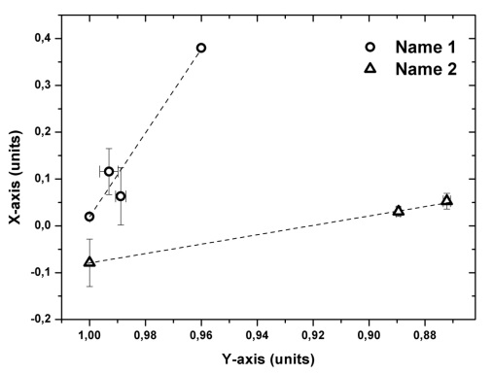
Figure 1. Figure name

The abstracts should be uploaded in the ABSTRACTS section of the conference site www.ils3.org/abstracts

Acknowledgments: This work was supported by ...

- M. Author, F. Author, Journal title 2014, 8, 82.
- S. V. Author, Journal title 2014, 53, 654.
- P. Author, Book (Editors, Honolulu 1891)

